Solar System Mobile
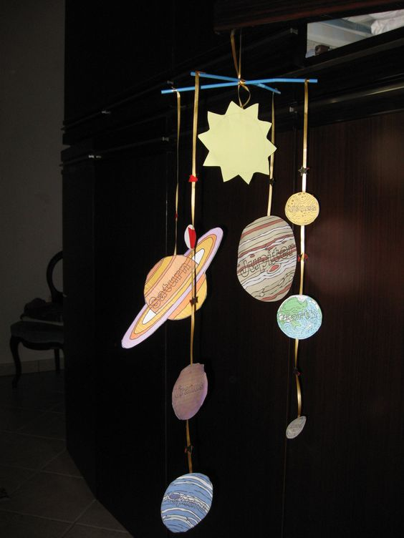

Use any die cuts you choose.
Cut out shapes in multiple colors.
Attach to straws or bamboo skewers using string and hole punch (I used a tooth pick).

