Galaxy Sensory Bottle

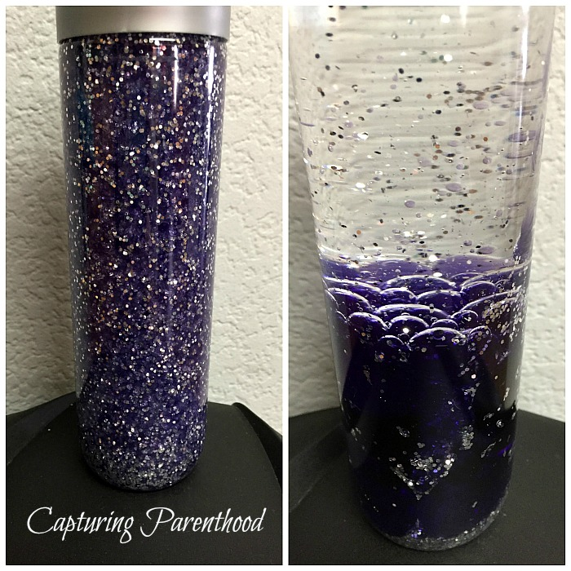
From: http://capturingparenthood.com/oil-water-galaxy-sensory-bottle/
Video of the bottle in motion: https://youtu.be/1LzxI_BKMl4

Materials
- Bottle with secure lid
- Baby oil
- Water
- Food color (purple and blue from the neon set used here)
- Glitter (silver used here)
- Hot glue

Instructions
- Empty the bottle. If it contained something other than water, clean it out.
- Remove all labels. If they are stubborn, Goo Gone works well.
- Fill the bottle half way with oil.
- Add a good sized amount of glitter.
- Add water to a glass (I used my 2-cup glass measuring device, because it conveniently has a pour spout)! Stir in approximately 8 drops of purple food coloring, and 5 drops of blue food coloring – or as many drops of each until you’ve created the perfect purple “galaxy” hue.
- Pour the colored water into the bottle, leaving a little bit of space at the top to allow the ingredients to move around.
- Add a dab of hot glue around the inside of the cap and quickly seal the bottle.

Galaxy Jar

Adapted from: https://youtu.be/rfFtZ5t_QiA
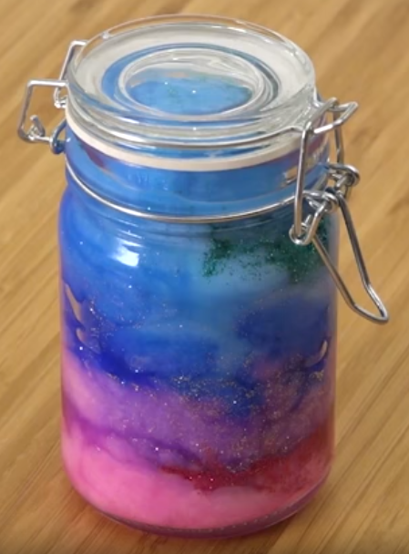
I recommend that you watch the video instructions. The video is 1:17 minutes and the instruction portion is less than a minute.

Materials
- Clean jar with a secure lid
- Water
- 3 or 4 different galaxy colors of kids’ paint (Crayola, tempura, etc.), small amounts of each
- 3 or 4 cups (one for each paint color) for holding water and paint mixture
- Stirrers (popsicle sticks work well)
- Cotton balls
- Glitter or glitter glue
- Star confetti (optional)
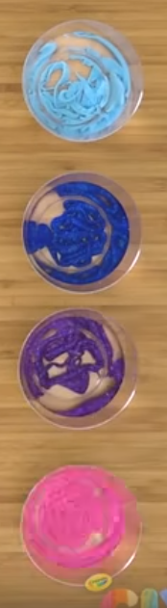
Instructions
- Pour water into cups.
- Add a different color of paint to each cup of water.
- Stir. If the color seems thin, add more paint.
- Flatten/pull apart several cotton balls and put into the jar.
- Add glitter or glitter glue. (If you’re using confetti, add that now as well.)
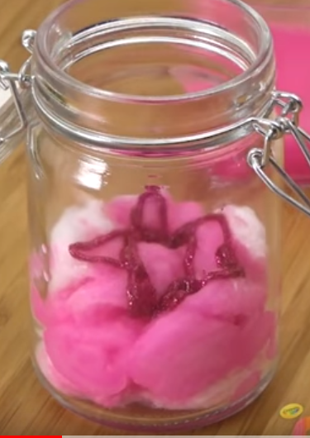
- Pour in a small amount of the first color and tamp down the cotton balls.
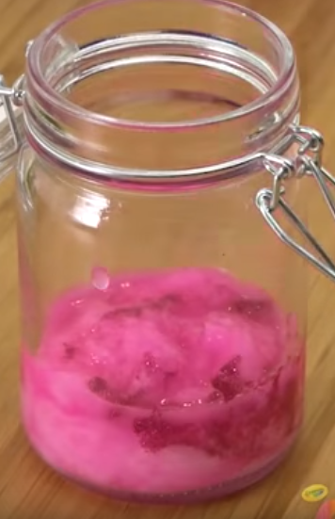
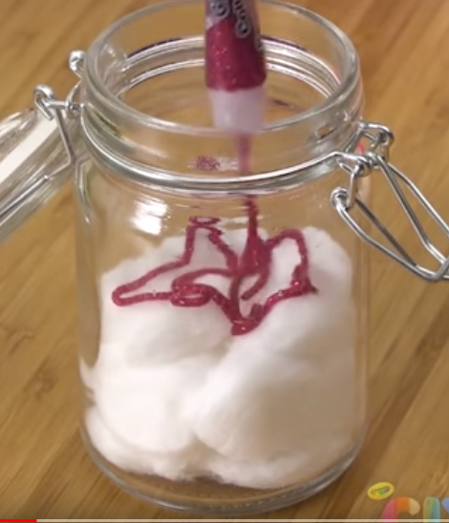

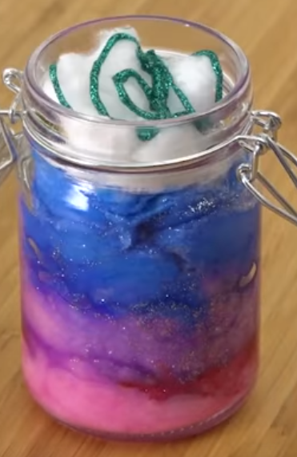
- Repeat steps 4-6 for each remaining color.
- When the jar is full, put the lid on securely.

Planet Bath Bombs
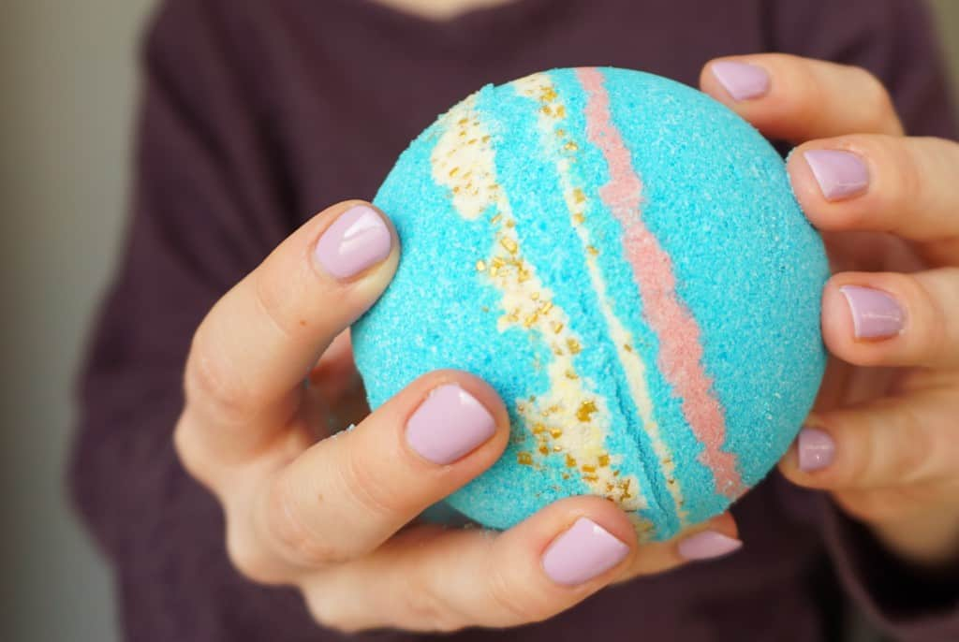
Adapted from: https://www.themakeupdummy.com/2015/12/21/diy-galaxy-bath-bombs/ and https://www.instructables.com/id/How-To-Make-Bath-Bombs/
Materials
- ½ cup baking soda
- ¼ cup citric acid
- ¼ cup cornstarch (some recipes substitute ¼ cup epsom salt, others added the salt in addition to the cornstarch and added an extra ½ Tbs. of oil, others did not include the salt at all)
- 1 Tbs. oil (coconut, pale olive, or something similar)
- Soap coloring (or food coloring)
- Water, if needed
- Optional: essential oil (be careful of allergies)
- 1 medium bowl
- Several smaller bowls (one for each color you’re using)
- Stirrer (or a gloved hand)
- Mold

Instructions
- Thoroughly mix together dry ingredients (baking soda, citric acid, cornstarch).
- Very slowly add in the tablespoon of oil. If you’re using essential oils, add that now, too.
  - Adding oil to quickly could cause the bath bomb to start fizzing, which you don’t want.
- Divide into smaller bowls, one for each color you want.
- Add color one drop at a time, stirring well between each drop, until the desired color is reached.
  - Adding the color too quickly could cause the bath bomb to start fizzing.
- At this point, the mixture should pack together when squeezed. If it’s too dry add a little water a drop at a time, stirring it in quickly to prevent fizzing.
- Once all of your colors are done, layer them into the mold pressing them firmly as you go along.
- Fill both sides of the mold (over-filling is better than under-fulling), then press together.
- You can gently remove half the mold almost as soon as the bath bomb is pressed together and let it dry in the other half of the mold.
- Let the bath bomb dry for a while (overnight is good).
- Gently peel or pull away the mold (don’t twist it).

