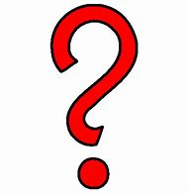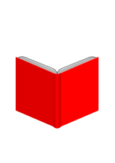

read a new author

Share a book review with us

Read a 2018 release or one from our new shelf

Watch a DVD that is a musical

Read a cookbook

Read a book of short stories

Read a Young Adult book

GO   
TO THE   
LIBRARY  
Attend one library program

GO   
Collect Knowledge and Entertainment

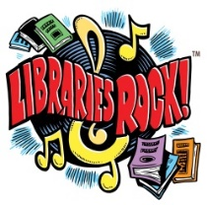



Viewing Terrace

Newbie Hill

Yum Yum Crescent

Teen Parkway

Short  
Esplanade

Take a  
CHANCE

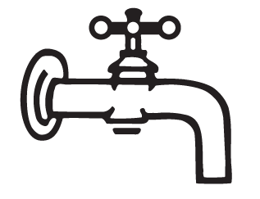

Read a book about mental health

Mental Health Roundabout

Listen to a Book on CD

Water Works

BOOKOPOLY

Read a Mystery

Read a Magazine

Thriller Drive

Magazine Alley

Receive a raffle ticket for each property (square) completed.   
That’s 23 possible tickets!  
Bring your Bookopoly board back to the library as often as you like   
to receive your tickets! (Games ends August 15)

Enter your tickets to win one of our fabulous prizes!

You will receive a raffle ticket to place in our grand prize drawing (held on 8/16) every time you complete all the spaces of one color; when you have completed any 12 Bookopoly squares; and when you complete the entire board!

Watch for other ways to earn raffle tickets!

Read a book with a musical instrument in the title

Listen to a music CD

Audio Way

Instrument Blvd.

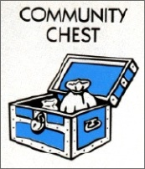

Read a Collection of Poetry

Read a NonFiction Book

Poetry Gardens

Free

Booking  
(read a book of   
your choice)

Reading  
Railroad

Singing Avenue

Sci Fi Circle

Fiction Court

Western   
Trail

Biography   
Plaza

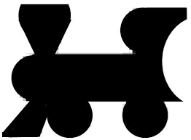

Read an adventure in the old west

Read a Science Fiction Book

Read a Fiction Book

Read a book with song lyrics in the title

Read a biography or memoir of a musician

Read a Graphic Novel