Book Horoscopes
What to read based on your astrological sign!

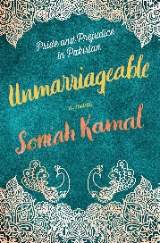  Aquarius (Jan 21-Feb 19)  Traits: Deep, imaginative, original, and uncompromising.  We Recommend: Unmarriageable by Soniah Kamal | Pisces (Feb 20-Mar 20)  Traits: Affectionate, empathetic, wise, and artistic.  We Recommend: Start Where You Are by Pema Chödrön
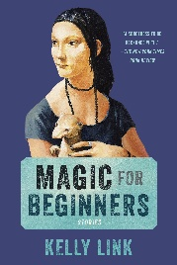  Aries (Mar 21-Apr 20)  Traits: Eager, dynamic, quick, and competitive.  We Recommend: Magic for Beginners by Kelly Link | Taurus (Apr 21-May 21)  Traits: Strong, dependable, sensual, and creative.  We Recommend: Save Me the Plums by Ruth Reichl
Gemini (May 22-Jun 21)  Traits: Versatile, expressive, curious, and kind.  We Recommend: Wunderland by Jennifer Cody Epstein | 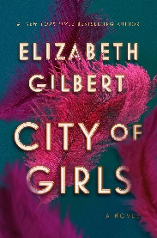  Cancer (Jun 22-Jul 22)  Traits: Intuitive, sentimental, compassionate, and protective.  We Recommend: City of Girls by Elizabeth Gilbert
Leo (Jul 23-Aug 22)  Traits: Dramatic, outgoing, fiery, and self-assured.  We Recommend: Inheritance by Dani Shapiro | 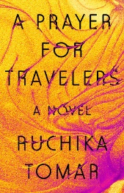  Virgo (Aug 23-Sept 22)  Traits: Practical, loyal, gentle, and analytical.  We Recommend: A Prayer for Travelers by Ruchika Tomar
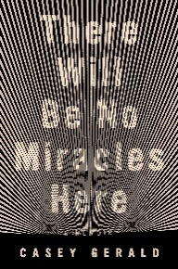  Libra (Sept 23-Oct 22)  Traits: Social, fair-minded, diplomatic, and gracious.  We Recommend: There Will Be No Miracles Here by Casey Gerald | 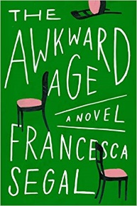  Scorpio (Oct 23-Nov 21)  Traits: Passionate, stubborn, resourceful, and brave.  We Recommend: The Awkward Age by Francesca Segal
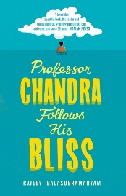  Sagittarius (Nov 22-Dec 21)  Traits: Extroverted, optimistic, funny, and generous.  We Recommend: Professor Chandra Follows his Bliss by Rajeev Balasubramanyam | 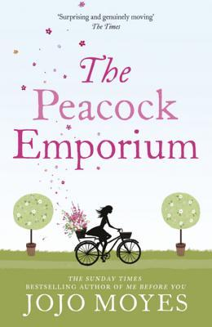  Capricorn (Dec 22-Jan 20)  Traits: Serious, independent, disciplined, and tenacious.  We Recommend: The Peacock Emporium by Jojo Moyes

Astrological Signs: www.horoscope.com/zodiac-signs
Literary Horoscopes: www.readitforward.com/specials/2019-literary-horoscopes/

