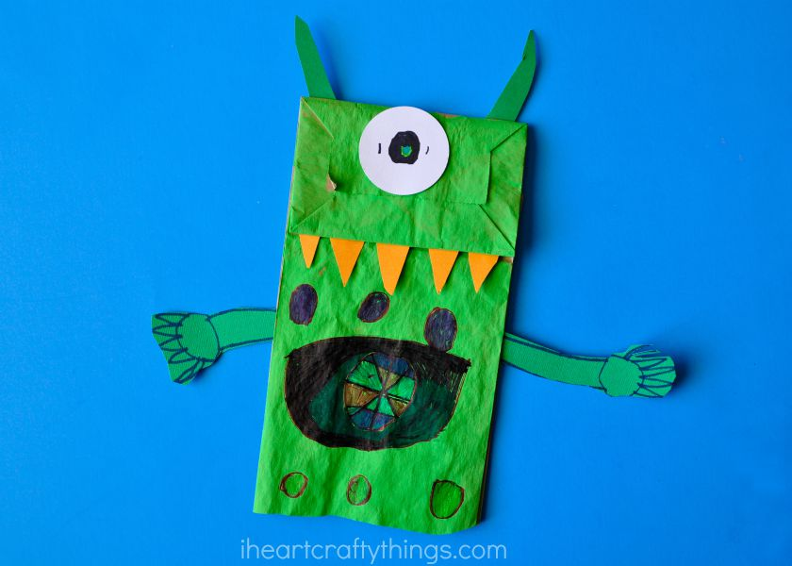
Alien Paper Bag Puppet

SUPPLIES:
- paper lunch bag
- acrylic paint (color of your choice)
- colored cardstock paper
- scrapbook scissors (optional)
- markers
- circle punches (optional-we used a 3-inch, 2-inch, 1 1/2-inch and 1-inch)
- scissors
- glue

INSTRUCTIONS:
- Decorate bag as wanted using paint, colored paper, markers, etc.

