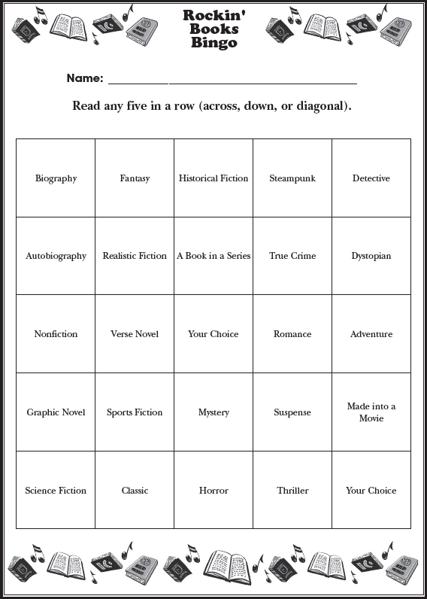
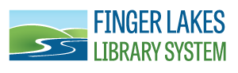

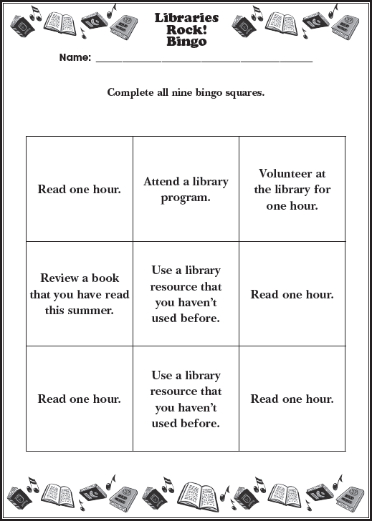

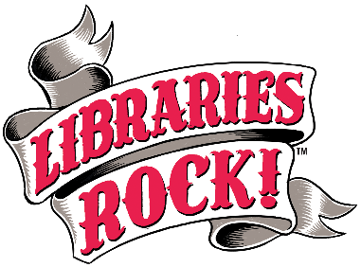
2018 Adult Summer Reading Program
The Finger Lakes Library System will be hosting an Adult Summer Reading Program June 25 through August 17. We will offer themed displays and suggested reading lists, biweekly raffles for readers, and a series of special events. Our goal is to promote library use and encourage adults in our community to make reading a priority. For a full list of events, please visit our website: flls.org

Program Title - Program Date
Lorem ipsum dolor sit amet, consectetur adipiscing elit.

Program Title - Program Date
Lorem ipsum dolor sit amet, consectetur adipiscing elit.

Program Title - Program Date
Lorem ipsum dolor sit amet, consectetur adipiscing elit.

Thank You to Our Sponsors:
CFCU Community Credit Union, Plantation Bar & Grill, Treeforms, Dunkin Donuts, & NYSEG.

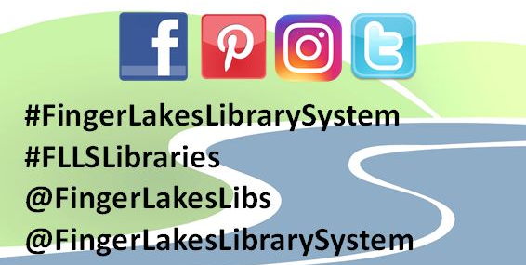

1300 Dryden Road • 607-273-4074 • flls.org
2018 Adult Summer Reading Program
The Finger Lakes Library System will be hosting an Adult Summer Reading Program June 25 through August 17. We will offer themed displays and suggested reading lists, biweekly raffles for readers, and a series of special events. Our goal is to promote library use and encourage adults in our community to make reading a priority. For a full list of events, please visit our website: flls.org

Program Title - Program Date
Lorem ipsum dolor sit amet, consectetur adipiscing elit.

Program Title - Program Date
Lorem ipsum dolor sit amet, consectetur adipiscing elit.

Program Title - Program Date
Lorem ipsum dolor sit amet, consectetur adipiscing elit.

Thank You to Our Sponsors:
CFCU Community Credit Union, Plantation Bar & Grill, Treeforms, Dunkin Donuts, & NYSEG.

1300 Dryden Road • 607-273-4074 • flls.org

