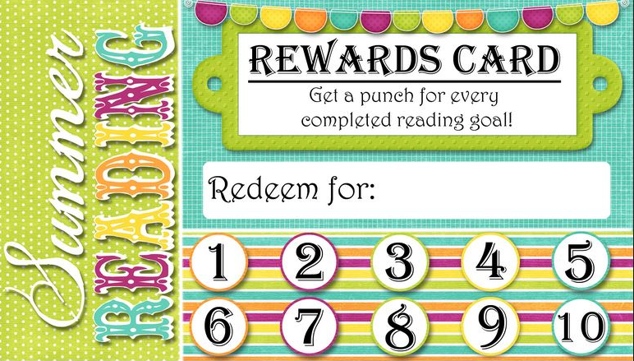

**Rewards Card**

Get a punch for every completed reading goal!

YOUR LIBRARY

Summer Reading

**Redeem for:**