CD Scratch Art

Supplies:
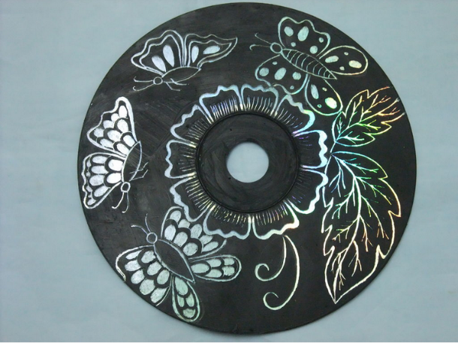
1. Any old CD
2. Acrylic color (preferably dark color)
3. Paint brush
4. Pencil
5. Anything with sharp point to scratch the color
- Toothpick
- Arm of a screwdriver
- Skewers

Procedure:

- Apply the acrylic color on shiny side of the CD. Make sure you have a thick layer of this color so that it becomes easy to scratch the color later
- Leave it to dry
- Using a pencil, draw your design onto the CD (optional).
- Using a sharp point, scratch the design into the disk.
- Decorate with them as you want (walls, frames, etc)

Design from http://www.instructables.com/id/CD-Art/?ALLSTEPS

