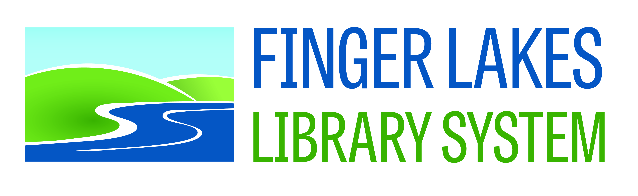
Connecting public libraries in
Cayuga, Cortland, Seneca, Tioga, and Tompkins Counties

NOMINATION FORM
Finger Lakes Library System Board of Trustees
Term: 2014-2018
PLEASE SUBMIT TO AMY STARR ZUCH AT FLLS BY AUGUST 16, 2013

Person submitting nomination:

Biographical information about the nominee:

Name:

Address:

Education / Employment:

Community/Library Services:

Personal Statement:
(Please describe the reasons for seeking a seat on the FLLS Board. Attach an additional sheet for any of the above information if necessary.)

I, ________________________, hereby affirm my intention to run for a seat
(Signature)
on the Finger Lakes Library System Board of Trustees and further affirm that I shall attend a majority of the meetings held by the Board of Trustees each year, should I be elected.

