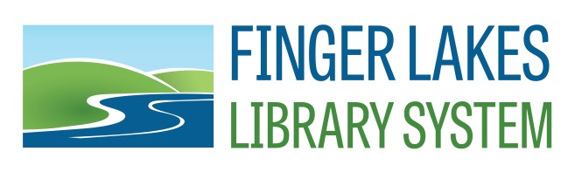
Social Media Procedure

For all accounts:

- Check at least once per day.
- Respond, Like, Comment etc. as needed to our followers.
- Adhere to our Social Media Policy.

Facebook
www.facebook.com/fingerlakeslibrarysystem

Access: Personal Facebook account is added by an Admin

Facebook has been changing the way pages are displayed in individual’s news feeds. In order to maintain maximum visibility. The following procedure is in effect:

Best Practices:
- Check FLLS Facebook page BEFORE you post or schedule something.
  - Another staff member may already have posted it previously or scheduled it to be posted.
  - Another staff member may have posted something recently.
- When sharing an article, be sure to write at least 1-3 sentences about the article.
- Use hashtags and tag additional organizations using the “@” where appropriate.

Scheduling Posts:
- Memes, Closings and other discussion oriented fun posts are scheduled in advance.
- There should be at least one scheduled post for every day of the year.

Live Posts and Sharing.
- Twice a day, approved Facebook staff at FLLS, will look through the Pages Feed on the left hand side of Facebook and be sure to Like all member library posts as FLLS.

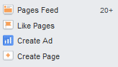

- Make sure to change the Like from your personal Facebook to FLLS Facebook using the dropdown menu by the comment bar:

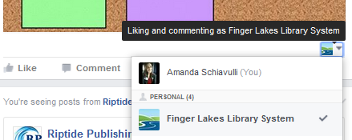

  - If you want to Like a FLLS post on your personal account, remember to change it back. It is not a good practice to Like your own posts; of course we like it, we posted it!

- At least Once Per Day, FLLS should find and share a member library post to the Finger Lakes Library System Facebook page. Be sure to write a sentence or two about the post and tag appropriately using @ and #.

- Live sharing should be done around lunchtime and evening time for optimal exposure

Best times to post:
- Daily between 6:30-8:30am, 1pm-4pm, and 6-8pm.
- Save best content for Thursday and Friday afternoons.

Twitter
https://twitter.com/FingerLakesLibs
Handle: @FingerLakesLibs

Access:
Username:
Password:

Primarily used to promote upcoming trainings and webinars being offered primarily by FLLS, but also includes outside sources such as Webjunction, SCLRC, ALA, etc. and viewed directly by our Twitter followers as well as visible on the Twitter widget on our home page (coming soon).

Twitter is also used to promote our Facebook, Instagram, website and share member library posts. At this time our Facebook posts automatically populate our Twitter.

Best Times to Post:
- Daily between 1-3pm

Pinterest
www.pinterest.com/flls

Access:
Username:
Password:

At this time anyone can post to our Pinterest. Create boards and have fun!

Best Times to Post:
- Daily 2-4am/pm, 1-3pm
- Fridays at 3pm
- Saturdays from 8-11pm

Instagram:
https://www.instagram.com/fingerlakeslibrarysystem/
Handle: @fingerlakeslibrarysystem

Access:
Username:
Password:

Instagram is used to post photos, memes and other related images from FLLS. Instagram can help to populate our Facebook account and maintain visibility on the platform. At this time posts cannot be scheduled and must be posted via cell phone or iPad. Posts will be updated daily. At this time Instagram is not connected to our other platforms.

Best Practices:
- Always use hashtags to link up to other library content. Popular library hashtags include: #librarianlife, #library, #libraryproblems, #librarylife, #lovemylibrary
- Always check a new hashtag before you use it. Some hashtags may have negative or unprofessional results.

Best Times to Post:
- Daily between 8-9am, 5pm, 2am

Related Resources:

- Start a revolution : stop acting like a library by Ben Bizzle
- Marketing and social media : a guide for libraries, archives, and museums by Christie Koontz
- The librarian's nitty-gritty guide to social media by Laura Solomon
- http://coschedule.com/blog/best-times-to-post-on-social-media/
- https://socialmediaweek.org/blog/2015/04/valuable-lessons-5-shockingly-bad-social-media-fails/
- http://www.sitesell.com/blog/2015/02/top-10-dos-and-donts-of-social-media-for-business.html
- http://www.techsoupforlibraries.org/blog/dive-into-the-world-of-library-hashtags
- http://lj.libraryjournal.com/2016/02/academic-libraries/ncsu-offers-social-media-archives-toolkit-for-libraries/

