Paper Tube Telescope and Constellations

Variation on the project found here: http://mommaowlslab.blogspot.com/2013/09/diy-constellation-tubes.html.
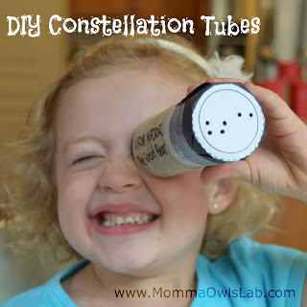
Materials
- Toilet paper tube
- Optional: Decorations for tube (paint, crayons, stickers, colored paper, duct tape, etc.)
- Black construction paper, cut into 2” x 2” squares
- Scissors
- Glue stick
- Push pin (large is better for small hands, an adult could use an awl for a substitute)
- Corkboard or cardboard or similar surface to poke pin against

Instructions
- Print out the constellation patterns.
- Cut out constellation patterns.
- Decorate the toilet paper tube telescope.
- Glue the constellation squares to the construction paper squares.
- One at a time, place the squares onto your corkboard (or similar surface) and use the push pin to poke out the constellations. This allows the light to come through, making the stars.
- Hold a completed constellation square to the end of the telescope with the black side against the tube. Look through the telescope at the constellation. Do not point the telescope directly at a light source (do not look directly at the sun ever).

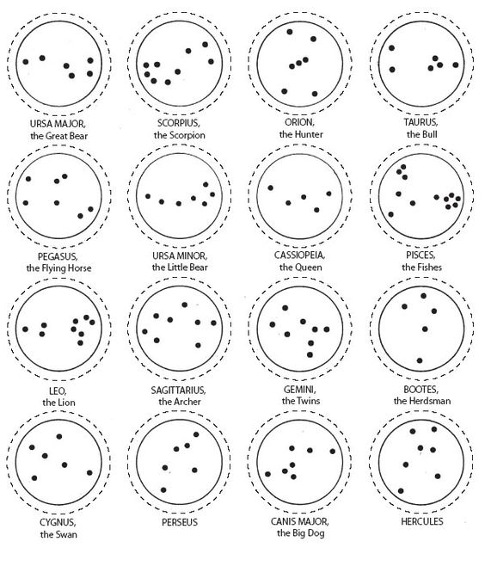
This is how the constellations look in the sky. To look through the telescope and see them this way use the print version, which inverts the images.

Print version

Taurus, the Bull | Orion, the Hunter | 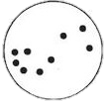  Scorpius, the Scorpion | Ursa Major, the Great Bear
Pisces, the Fish | Cassiopeia, the Queen | 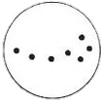  Ursa Minor, the Little Bear | 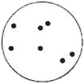  Pegasus, the Flying Horse
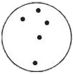  Bootes, the Herdsman | Gemini, the Twins | 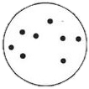  Sagittarius, the Archer | Leo, the Lion
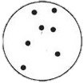  Hercules | Canis Major, the Great Dog | Perseus | 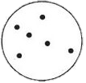  Cygnus, the Swan

