DLTK's Crafts for Kids
Moon Paper Plate Craft
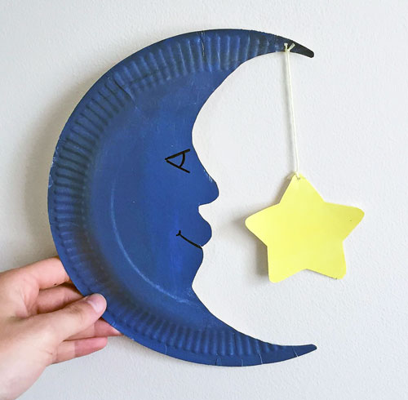
Using a paper plate and some creative scissor and painting skills children can create an adorable moon craft with an interactive dangling star.
This is a great craft for a space or night sky theme or to suit several nursery rhymes, poems, and stories like Twinkle Twinkle Little Star, New Moon, and The Moon Maiden.

Materials:
- paper plate,
- scissors
- paint (blue, grey, and yellow),
- string or wool,
- printer and paper (optional)

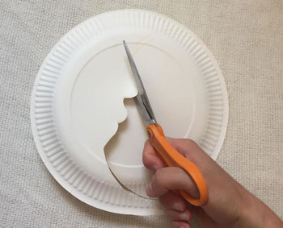
Instructions:
- Trace a moon shape onto the back of a paper plate. You can do this free hand or print out our template and cut out the moon we have provided to use as a tracer.
- Cut out the moon-shape from the paper plate.

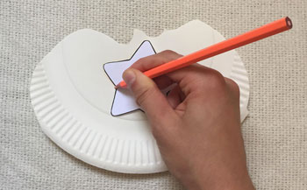
- Trace a star (again you can use the provided template or freehand) on the left over piece of paper plate and cut it out.

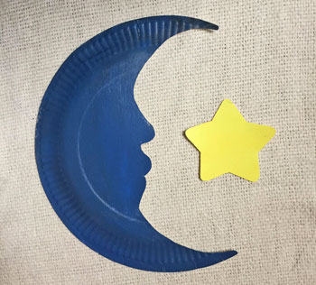
- Paint the back of the moon paper plate (I used a blue grey but you can choose whatever colour you would like!) and both sides of the star.

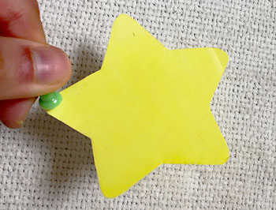
- Punch a hole in the top of the moon and the top of the star (I used a push pin to make small holes).

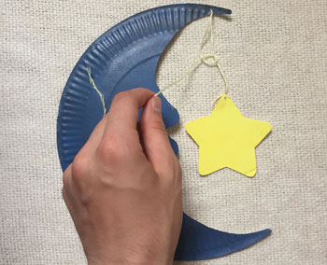
- Cut a piece of string or wool. Tie the string to both holes in order to attach the star to the moon.

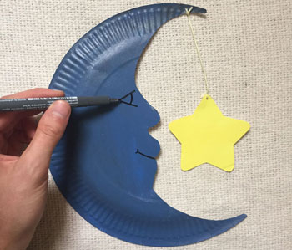
- Draw a face onto the moon with a marker or pen.

