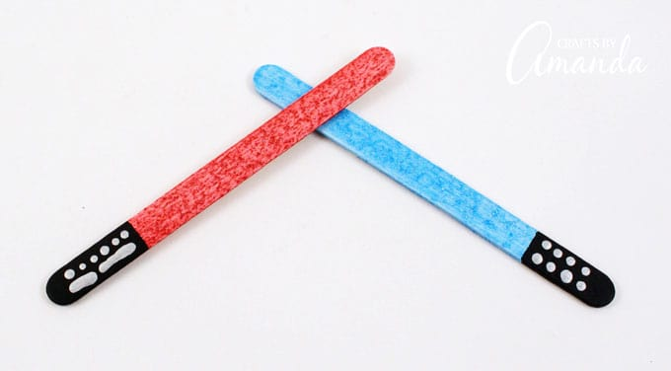

WHAT YOU NEED TO MAKE LIGHTSABER BOOKMARKS:
- Craft sticks
- Craft paint: white, black, silver
- Glitter craft paint in colors of your choice
- Toothpick

HOW TO MAKE LIGHTSABER BOOKMARKS:
Paint craft sticks white and then let them dry completely.
Paint all but ¾-inch with glittered craft paint and repeat for a second coat.
Paint the end of the stick black. Use a toothpick dipped in silver paint to add dots and/or lines to the handles (black).
https://craftsbyamanda.com/lightsaber-bookmarks/

