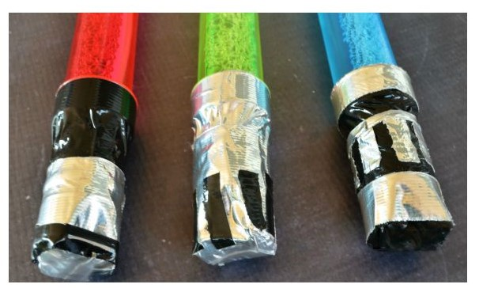
Bubble Light Saber

SUPPLIES
bubble wands
black duct tape
silver duct tape

DIRECTIONS:
Cut 2 strips of duct tape long enough to overlap the bubble wand handle.
Cut accent strips to complete your lightsaber hilt.

https://eclecticmomsense.com/lightsaber-bubbles-star-wars-party-favor/

