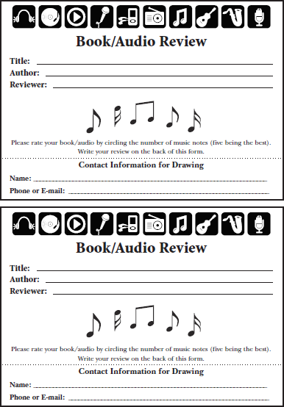

**TRIVIA**

**A:** ________________________________________

**TRIVIA**

**A:** ________________________________________

**TRIVIA**

**A:** ________________________________________

**TRIVIA**

**A:** ________________________________________