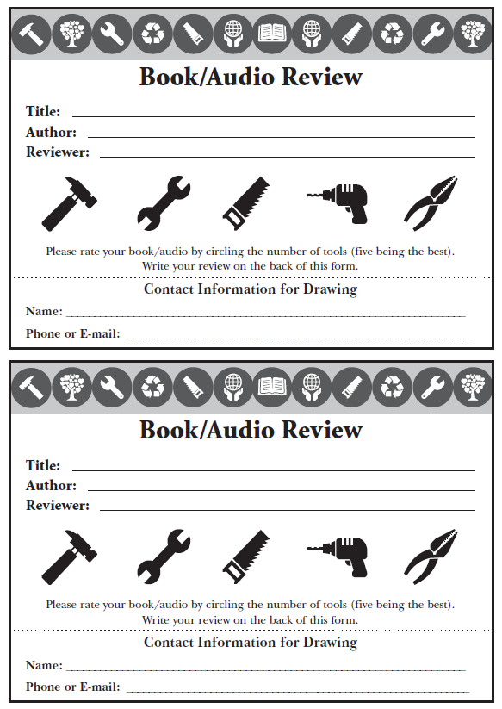



**TRIVIA**

**Q:** *This was built for the 1962 World’s Fair:*

**A:** ________________________________________



**TRIVIA**

**Q:** *Name the capital of Pennsylvania:*

**A:** ________________________________________



**TRIVIA**

**Q:** *Many spices and herbs have ancient histories of causing wars and expanding exploration. What is caraway’s place of origin?*

**A:** ________________________________________



**TRIVIA**

**Q:** *This is the most popular woodworking tool, used for carving work and cutting edges, among many other things:*

**A:** ________________________________________