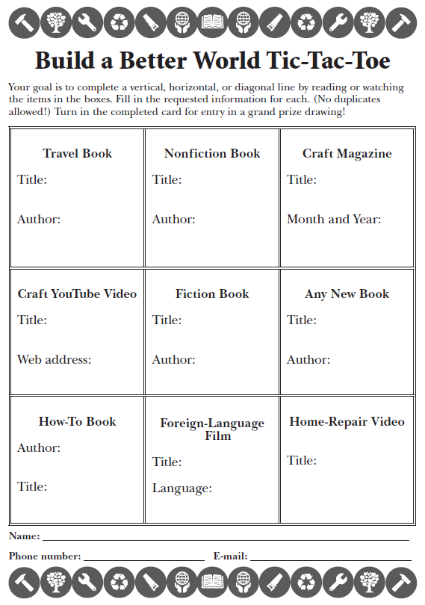

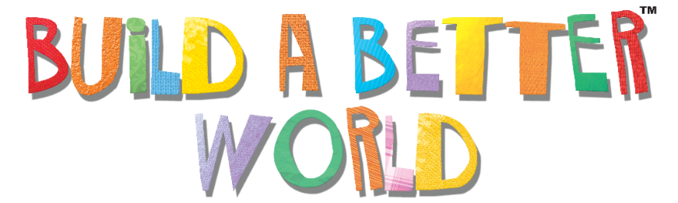
2017 Adult Summer Reading Program
The Finger Lakes Library System will be hosting an Adult Summer Reading Program June 29 through August 22. We will offer themed displays and suggested reading lists, biweekly raffles for readers, and a series of special events. Our goal is to promote library use and encourage adults in our community to make reading a priority. For a full list of events, please visit our website: flls.org

Program Title - Program Date
Lorem ipsum dolor sit amet, consectetur adipiscing elit.

Program Title - Program Date
Lorem ipsum dolor sit amet, consectetur adipiscing elit.

Program Title - Program Date
Lorem ipsum dolor sit amet, consectetur adipiscing elit.

Thank You to Our Sponsors:
Bernard’s Custom Logo & Trophy Source, CFCU Community Credit Union, Central City Bar & Grill, Crown City Steakhouse, The Daily Grind, Hollywood Restaurant, Hummel’s Office

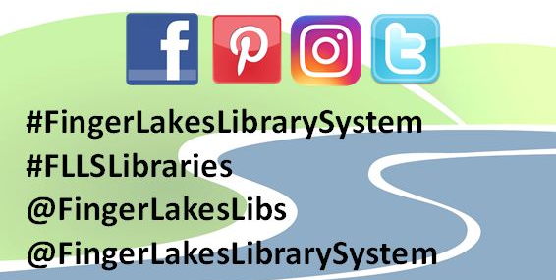

1300 Dryden Road • 607-273-4074 • flls.org
2017 Adult Summer Reading Program
The Finger Lakes Library System will be hosting an Adult Summer Reading Program June 29 through August 22. We will offer themed displays and suggested reading lists, biweekly raffles for readers, and a series of special events. Our goal is to promote library use and encourage adults in our community to make reading a priority. For a full list of events, please visit our website: flls.org

Program Title - Program Date
Lorem ipsum dolor sit amet, consectetur adipiscing elit.

Program Title - Program Date
Lorem ipsum dolor sit amet, consectetur adipiscing elit.

Program Title - Program Date
Lorem ipsum dolor sit amet, consectetur adipiscing elit.

Thank You to Our Sponsors:
Bernard’s Custom Logo & Trophy Source, CFCU Community Credit Union, Central City Bar & Grill, Crown City Steakhouse, The Daily Grind, Hollywood Restaurant, Hummel’s Office

1300 Dryden Road • 607-273-4074 • flls.org

