Perler Beads

Directions:
- Using perler beads and peg board, create a design.
- Put a piece of wax paper (parchment paper) over the design.
- Iron over the wax paper until the beads are melted together.

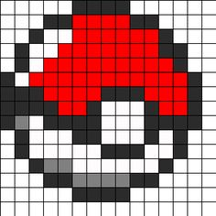
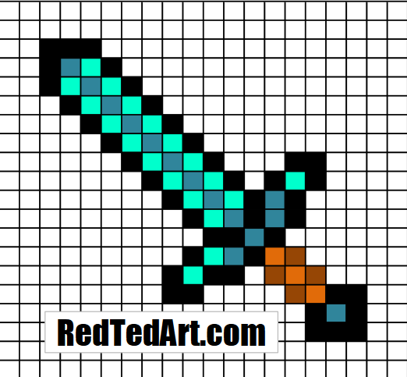
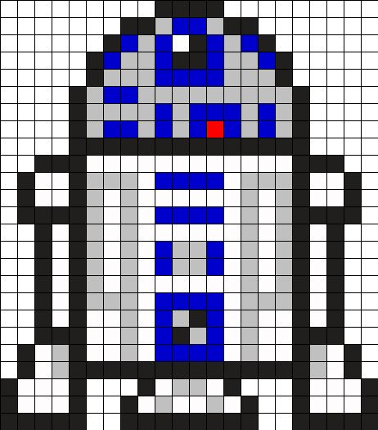
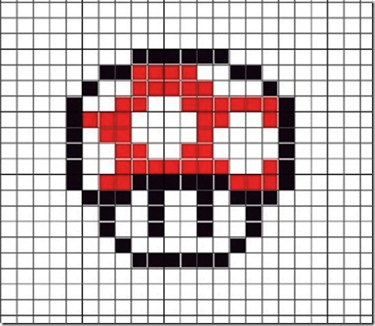
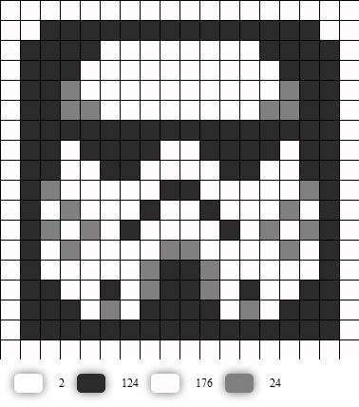

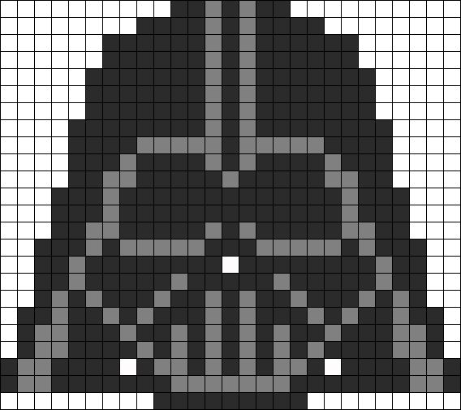

Resources:
http://www.u-createcrafts.com/star-wars-perler-bead-patterns/
http://www.redtedart.com/minecraft-crafts-diamond-sword-perler-beads/
http://www.minieco.co.uk/minecraft-design-sheets-hama-beads-paper-mosaic/
http://www.wikihow.com/Use-Perler-Beads

