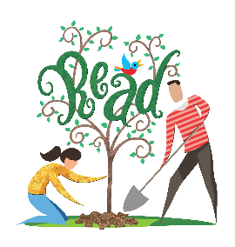
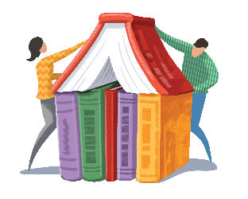
FLLS Bucket List
2017 Adult Summer Reading Program
Cross as many items off the FLLS Bucket List as you can by attending summer events, answering trivia questions, and exploring library resources for a chance to win a prize pack including (4) Redbox® Rentals, a gift certificate to Central City Bar & Grill, and (2) popular fiction books. Complete 10 items to be entered into the grand prize drawing. Entries are due by August 21. The winner will be announced on August 22.

- What is your favorite thing about the library:

- Read a magazine or newspaper in the library. Name the magazine or newspaper:

- Attend a library event of your choice (see flip side for a list of events). Which event did you attend? When was it:

- Check out and read a book that appears on one of the library’s suggested summer reading lists. Name the title and author:

- Enter a Bi-Weekly Raffle! Name the book you reviewed or the trivia question you answered:

- “Like” the Finger Lakes Library System on Facebook. How many likes do we currently have?

- “Follow” the Finger Lakes Library System on Twitter. How many followers do we currently have?

- “Follow” the Finger Lakes Library System on Instagram. How many followers do we currently have?

- Check out a cookbook from the library and try out a new recipe. Name the cookbook:

- Suggest an event, workshop, or program you’d like to see the library offer:

- Use Mango Languages, the library’s online language-learning database, to learn a new word or phrase in a foreign language. Share the word or phrase you learned:

- Read a book or watch a movie that you ordinarily wouldn’t pick out on your own—ask a staff person for a recommendation. What is the title?

- In what year was the Finger Lakes Library System building built:

- Check out a graphic novel. What is the title?

1300 Dryden Road • 607-273-4074 • flls.org
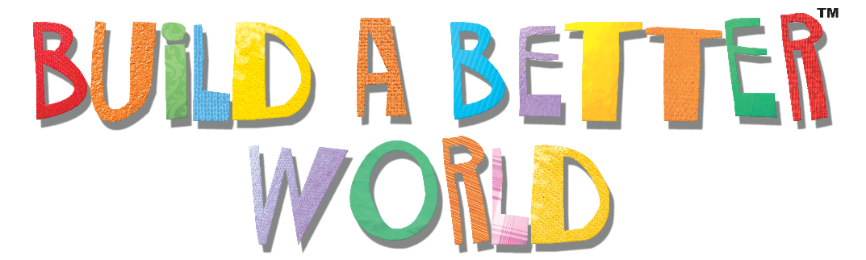
2017 Adult Summer Reading Program
The Finger Lakes Library System will be hosting an Adult Summer Reading Program June 29 through August 22. We will offer themed displays and suggested reading lists, biweekly raffles for readers, and a series of special events. Our goal is to promote library use and encourage adults in our community to make reading a priority. For a full list of events, please visit our website: flls.org

Program Title - Program Date
Lorem ipsum dolor sit amet, consectetur adipiscing elit. Etiam quis laoreet nulla, id laoreet quam. Nunc sollicitudin in libero id bibendum. Vestibulum convallis felis tortor, ac elementum ligula gravida a. Proin varius non justo non egestas.

Program Title - Program Date
Lorem ipsum dolor sit amet, consectetur adipiscing elit. Etiam quis laoreet nulla, id laoreet quam. Nunc sollicitudin in libero id bibendum. Vestibulum convallis felis tortor, ac elementum ligula gravida a. Proin varius non justo non egestas.

Program Title - Program Date
Lorem ipsum dolor sit amet, consectetur adipiscing elit. Etiam quis laoreet nulla, id laoreet quam. Nunc sollicitudin in libero id bibendum. Vestibulum convallis felis tortor, ac elementum ligula gravida a. Proin varius non justo non egestas.

Thank You to Our Sponsors:
Bernard’s Custom Logo & Trophy Source, CFCU Community Credit Union, Central City Bar & Grill, Crown City Steakhouse, The Daily Grind, Hollywood Restaurant, Hummel’s Office

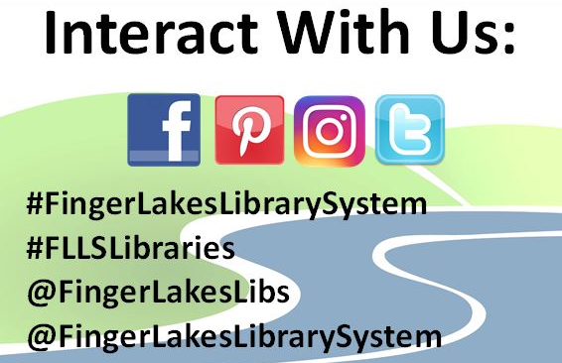

1300 Dryden Road • 607-273-4074 • flls.org

