T-Shirt Dog Toy Craft/Service Project

Directions:
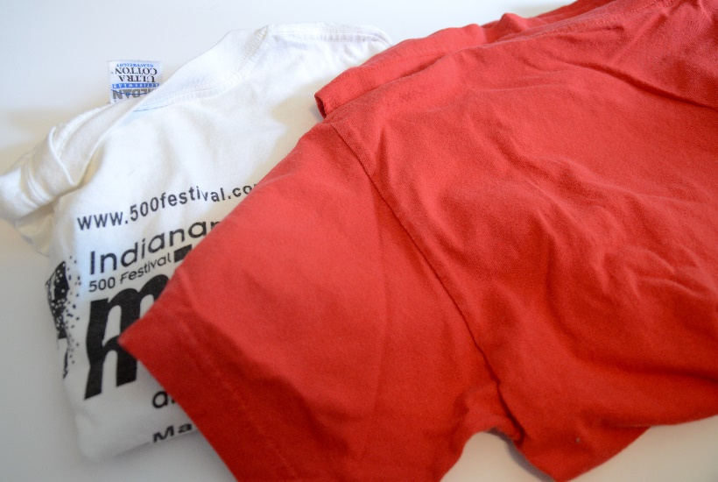
For this project, the only things you need are two used t-shirts and a pair of scissors.
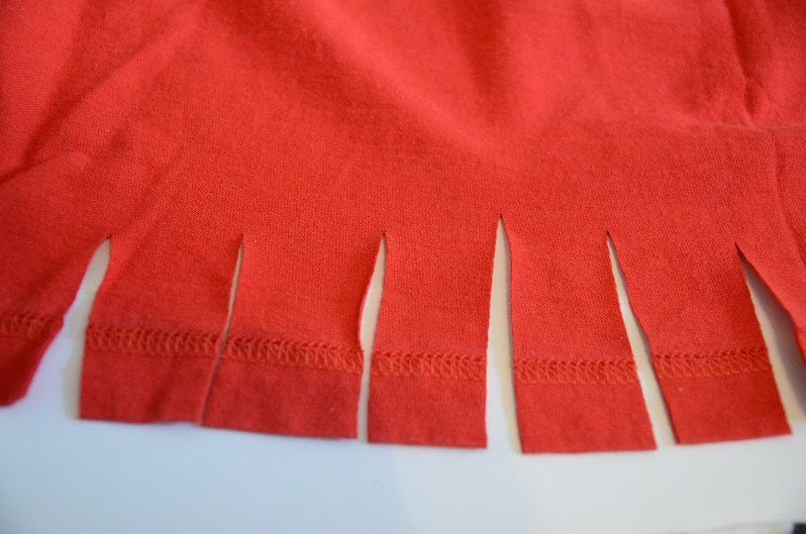
Start by cutting little 2-3” wide slits at the base of your shirts. After you’ve cut your slits, just rip along the slit and your t-shirt will have the perfect strips of fabric for the next step.
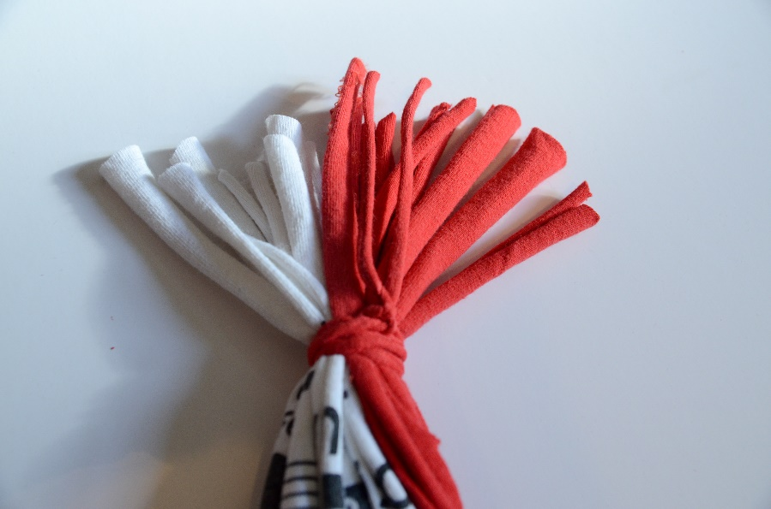
Gather your t-shirt strips and tie off one end. Divide your strips into thirds and braid them together.
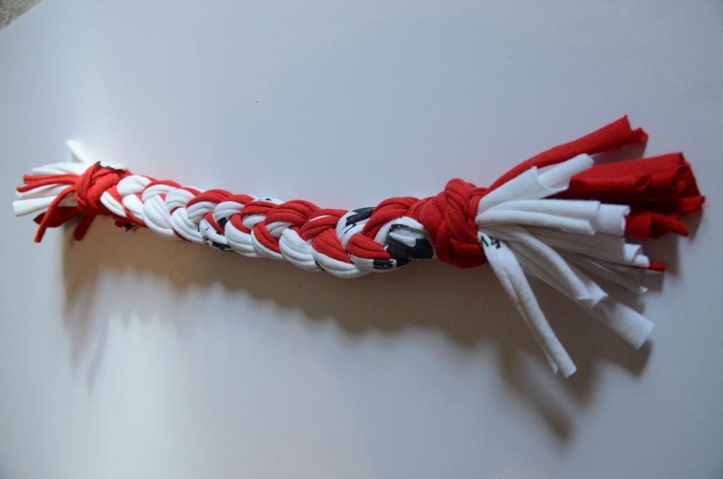
Once you’ve braided down to the other end, tie up the bottom and cut any straggling t-shirt strips.

From: http://stories.barkpost.com/how-to-make-a-t-shirt-dog-toy/

