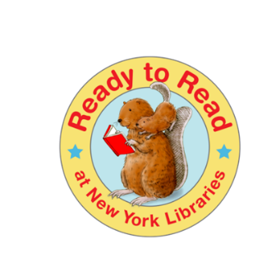
2016-2019
Ready to Read Training
Early Literacy purchase Request
Support questions

Date:______________ Your Name: ___________________________________________________
Library Affiliation:___________________ Email:_________________________________________

- Please describe what you plan to purchase for your Early Learning space:

- How will your space create a good first impression for families?

- What type of signage will you have?

- How will you place the item(s) so children interact with them appropriately?

- Which elements of Open-Ended Play will the item(s) support?

- How will the item(s) support the 5 Active Learning Ingredients?

Funding is made possible through the 2016-2019 New York State Library Family Literacy Library Services Grant.

