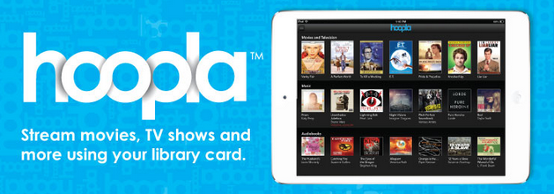
2016-2017 Hoopla Member Library Contribution Form
Library Information:
Name of Library:
Library Code:

Primary Contact:
Name:
Telephone:
Email:
Billed to Address:

Please bill above in the amount of $_____________, for the purchase of Hoopla for 2016-2017
Payment is due within 30 days of invoice.

Acknowledgement and Acceptance:
On behalf of my Library, I represent and warrant that I have the authority to enter into this Agreement and my signature below indicates my Library’s agreement and acceptance of the above purchase.

By (signature):___________________________ Title:_____________________________

Name (Print): ___________________________ Effective Date:______________________

Submit completed order forms to Amanda Schiavulli via delivery or at aschiavulli@flls.org

