at the Seneca Falls Library

Welcome to the 2013 Summer Reading Program!
We’re sure that the program we have put together is going to help you have fun, learn a lot, be inspired to CONTINUE READING all summer long (in AND out of the library) and maybe even make some new friends along the way!

Getting started: It’s really quite simple. When you register, you’ll receive a game piece to add to the GO square on the WORMWORLD game board on the wall in the Children’s section. You’ll use your game piece all summer to play the game and win prizes!

In this folder you’ll find: a calendar filled with all the summer events, a reading log to keep track of your progress, a summer reading list, and a fun activity! My suggestion is to take a few minutes to look over the calendar with an adult and circle the programs that seem most appealing, making it easier to fit as many as possible into your family’s busy schedule. Hopefully you can find one or two activities each week that sound fun and work with your schedule!

You can use the reading log to keep track of your reading in two ways: either by tracking the minutes you read (or are read to) each day or by tracking the number of books you read. Either way is fine, so do what’s best for you!

Moving your game piece: Each time you return to the library for a scheduled program, there will be a check-in station where you can talk with one of our volunteers about some of your favorite books you’ve been reading. If it’s easier for you to bring the reading log each week to show off, then do so. If not, then you can just tell us about your reading. Then, the fun really begins when you get to roll the die and move your game piece along the board! Each time you pass through a prize space, you may choose something from the prize basket!

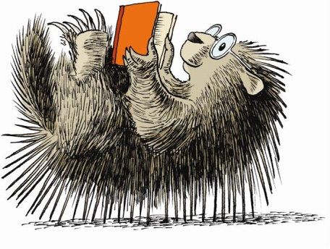
Finishing the game: What happens if you finish the game? If you do reach the finish line, then you get to begin the game again and earn even more prizes!
