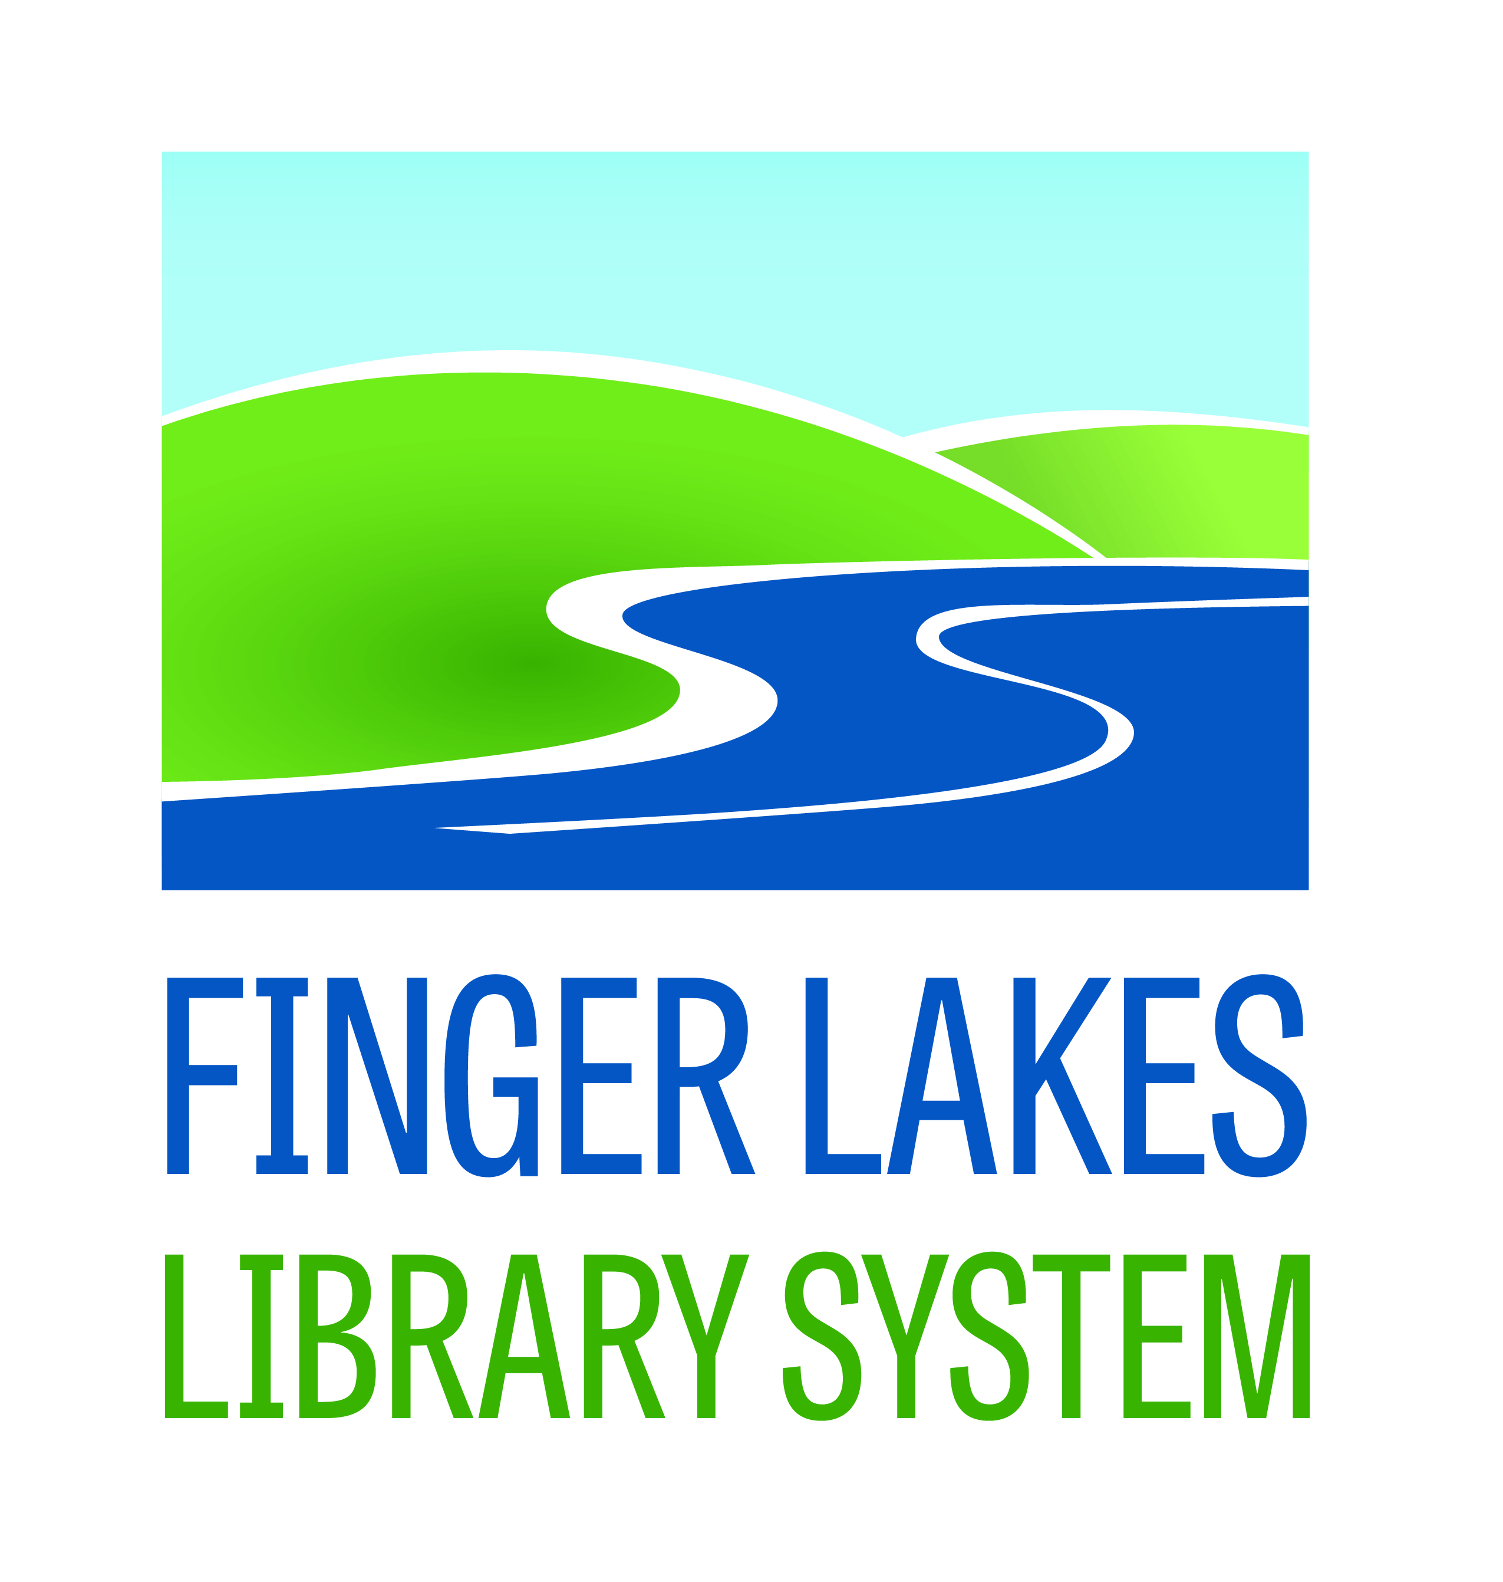

2014-2015 Outreach Mini Grant Final Report

Due to aschiavulli@flls.org or https://www.surveymonkey.com/s/28GBDHH
by June 30, 2015

MEMBER LIBRARY:
CONTACT PERSON:
PHONE/EMAIL:
GRANT AMOUNT:
PROJECT NAME:

TARGET POPULATION(s): Which population(s) did this grant serve:

Educationally disadvantaged (i.e. people who have
below-average skills with reading, writing, or basic computer literacy)
Ethnic minorities
Geographically isolated
Jobseekers (including people who are unemployed/underemployed)
Persons with criminal records
Persons with physical, visual, or developmental disabilities
Residents of institutions (examples include correctional facilities, hospitals, youth facilities, nursing homes)
Seniors (defined as 55+)

EVALUATION:

- What was the overall goal of the project? How did having this project benefit, change, or impact the individuals it served?

- How many people benefitted from adding this service?

- Did you include a community partner? What role did they serve in this service?

- Describe any challenges or surprises you faced.

- How did measure your outcomes? Please attach a copy of the form you used and the compiled data from your participants. Please include any anecdotal information and/or photos of the projects as well. *For any photos submitted, it is the library’s responsibility to have a photo release document in their files.

- Do you have future plans for this project?

- How did you share the success of this project?

BUDGET:

Please compare your original budget with actual figures. Explain any variations from original budget.

Submit all Final Reports to Amanda Schiavulli at aschiavulli@flls.org or online at https://www.surveymonkey.com/s/28GBDHH

